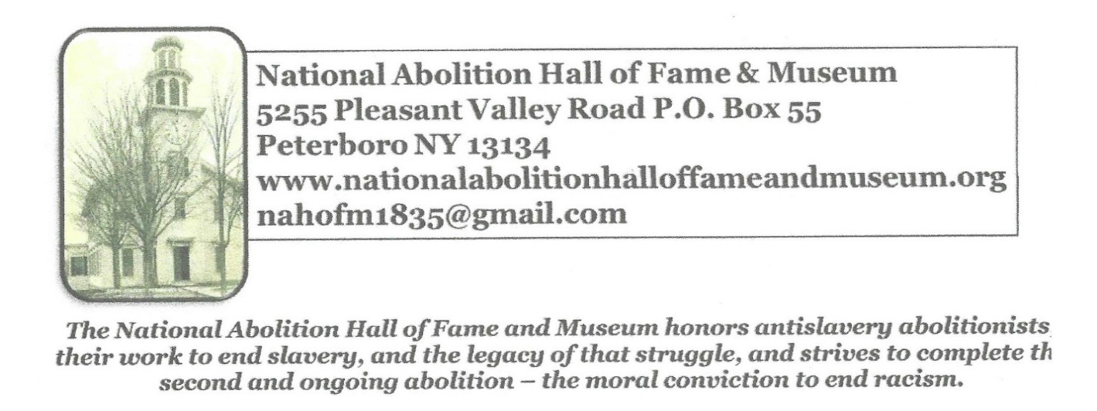

Public Nomination for Induction to
National Abolition Hall of Fame and Museum
(NAHOF)

Criteria for Induction to the National Abolition Hall of Fame and Museum

The National Abolition Hall of Fame and Museum (NAHOF) invites persons or organizations to nominate abolitionists who worked in the United States for the immediate abolition of slavery, and who made a significant impact in the abolition movement prior to 1870.

● Recognizable abolition activities include (but are not limited to):
○ Publisher/editor of an abolition newspaper or journal
○ Author of books, pamphlets, and/or articles that advocated the immediate
abolition of slavery
○ Antislavery orator
○ Underground Railroad stationmaster/conductor/vigilance committee member
○ Political leader at the local, state, or national level active in the abolition crusade
○ Religious leader of antislavery denomination or institution
○ Philanthropist and donor to antislavery movement
○ Educator or administrator at integrated/abolitionist school
○ Involvement with local, state, or national antislavery organizations

● Recognition by noted abolitionists, especially current inductees on NAHOF website:
www.nationalabolitionhalloffameandmuseum.org

Public Nomination for Induction to
National Abolition Hall of Fame and Museum
(NAHOF)

Nomination Guidelines
The completed application is used to determine the merits of the nominee for induction into the National Abolition Hall of Fame and Museum. The application, materials, and information submitted become the property for NAHOF and are not returned. The applications also become the primary planning tools for the induction events and for future programs. The application may require networking with other persons and organizations so that others interested in participating in the ceremonies can be contacted.
● Please complete all information.
● Please clearly label each section of the application.
● Submit application to nahofm1835@gmail.com with copy to dwillsey@twcny.rr.com

Selection
The applications will be processed by the Induction Committee for the National Abolition Hall of Fame and Museum’s Cabinet of Freedom. The Induction Committee will forward copies of the applications to scholars in the field of abolition history to evaluate the suitability of the nominee for induction according to the criteria set forth in the nomination.
The Induction Committee will present a slate of nominees to the Cabinet of Freedom, which makes the final decision.
Thereafter, applicants will be notified of the status of their nomination.

Inductions are held every other year on the weekend closest to the anniversary of the inaugural meeting of the New York State Antislavery Society October 22, 1835 in Peterboro.

Refer to the NAHOF website for updates on nomination deadlines
www.nationalabolitionhalloffameandmuseum.org

Public Nomination for Induction to
National Abolition Hall of Fame and Museum
(NAHOF)

Nomination

Section 1. — Nominator(s) Information
a. Person(s) or Organization(s) submitting the nomination:

b. Address:

c. City, State/Province, Zip Code, Country:

d. Phone Number:

e. E-mail Address:

f. Web Site:

g. Brief nominator(s) bio (250 words) to be used for introductions, media releases, printed program, etc.

h. Resume of nominator(s).

h. Title of the forty minute program on the nominee for the Saturday afternoon Abolition Symposia during Induction Weekend:

i. Description of the Abolition Symposia program (500 words)

In the event that the nominator(s) will not be the speaker or first nominator, provide information on the persons who will present:
a. Person(s) presenting:
b. Address:
c. City, State/Province, Zip Code, Country:
d. Phone Number:
e. E-mail Address:
f. Web Site (if any):

Public Nomination for Induction to
National Abolition Hall of Fame and Museum
(NAHOF)

Nomination

Section 2. — Nominee Information
a. Nominee's Name:

b. Nominee's Birth Date:

c. Nominees’ Place of Birth:

d. Nominee's Date of Death:

e. Nominee’s Place of Death:

f. Nominee's Place of Burial:

g. Address of Place of Burial:

h. Short (approximately 1000 words) biography of individual that emphasizes the
nominee’s major contributions to immediate 19th C. abolitionism:

i. List the key points why this individual deserves induction into the National Abolition Hall of Fame.

Please explain the nominee’s significance to the 19th C abolitionist movement, including
- meets NAHOF’s criteria for activism and leadership,
- exceeds NAHOF’s criteria,
- or adds another important dimension to the history of abolition, and
- contributes to the diversity of abolitionists previously inducted in NAHOF

j. Identification: Provide evidence that this individual self-identified as an abolitionist
and/or that others identified this individual as an abolitionist.

k. Provide a bibliography of works by the nominee.

l. Provide a bibliography of works about the nominee.

m. Provide other supportive materials for the nomination.

Public Nomination for Induction to
National Abolition Hall of Fame and Museum
(NAHOF)

Section 3 – Hall of Fame Banner Information
Two 31 inch x 84 inch inductee retractable banners will be created for each inductee for the Hall of Fame with the following information provided by the nominator
a. Nominee's Name:
b. Nominee's Birth Date:
c. Nominees’ Place of Birth:
d. Nominee's Date of Death:
e. Nominee’s Place of Death:
f. Nominee's Place of Burial: Cemetery Name, Street Address, Town, State
g. Address of Place of Burial:
h. Year of induction

i. 50 word summary of the candidate’s abolition career.

j. Abolition quote (25 words) by the nominee:

k. Submit as many portrait images as possible of the nominee. An artist commissioned by
NAHOF will create the official Hall of Fame portrait using the images submitted. A large
image of the inductee portrait is created by Melissa Moschetti from the images provided
by the nominator(s). The artist’s creation is the property of NAHOF.

l. Two lines for each of the sponsors of the banners:
1st line: Name(s) of sponsor(s) town, and state
2nd line: Relationship to inductee (Exs: great, great grandson, author of biography,
director inductee’s museum, library)

m. The Cabinet of Freedom reserves the right to edit information provided for the
banners.

Public Nomination for Induction to
National Abolition Hall of Fame and Museum
(NAHOF)

Section 4 - Communications and Connections (Spreadsheets welcomed.)
a. Provide names and contact information (emails, postal addresses, street addresses, state, zip code, and phone numbers) of living descendants, as well as others who may be interested in the nominee, and, perhaps, supporting the induction banner.

b. Provide names and contact information (emails, postal addresses, street addresses, state, zip code, and phone numbers) of associated museums, historical homes and societies, organizations, and other groups affiliated with the inductee which may be interested in supporting the inductee banner.

c. Provide names and emails of media (broadcast, newspapers, social media, websites, etc.) in areas of the nominators.

d. Provide names and emails of media (broadcast, newspapers, social media, websites, etc.) in various locations of the nominee’s life and activities.

e. Nominators and NAHOF want to make every effort to contact persons who may be interested in the induction of a particular abolitionist so that they may support the nomination in some way.

Section 5 - Associated Programs and Information
- Provide ideas for speakers and / or presentations and/or exhibits related to nominee. Provide contact information for each.

- Attach other information that may support the nomination.

- Induction Weekend usually includes:
- Abolition Symposia Saturday afternoon, at which the nominator, or someone chosen by the nominator, presents a 30-40 minute program on the inductee.
- Antislavery Dinner Saturday around 5 pm with a 19th C. menu. There is sometimes a keynote address.
- A program related, in some way, to each inductee (other than the Abolition Symposia presentation) Friday night, Saturday morning, or Sunday morning
- Peterboro Mercantile
- National Abolition Hall of Fame and Museum is open
- Tours of the Gerrit Smith Estate National Historic Landmark
- Annual Meeting of the NAHOF members

Section 7 - Nomination Feedback
a. Provide feedback on the application process. NAHOF welcomes both kudos and opportunities for improvement:

Signed _____________________________________ Date _________

Rev. 4.12.22

Public Nomination for Induction to
National Abolition Hall of Fame and Museum
(NAHOF)

NAHOF INDUCTEE BANNERS

Two 31 inch x 84 inch inductee retractable banners will be created for each inductee for the Hall of Fame with the following information provided by the nominator
Two sets of inductee banners are ordered so that a complete set of inductee banners is in the
Hall of Fame, and another set is available to be rented by an organization for a temporary exhibit.

The banner information includes a large portrait of the inductee and
Nominee's Name:
Nominee's Birth Date:
Nominees’ Place of Birth:
Nominee's Date of Death:
Nominee’s Place of Death:
Nominee's Place of Burial: Cemetery Name
Address of Place of Burial:
Year of induction

The banner costs are supported by one hundred-dollar sponsorships.
Two lines at the bottom of the banner are reserved for each sponsor:
1st line: Name(s) of sponsor(s) town, and state.
2nd line: Relationship to inductee (Exs: great, great grandson, author of biography,
director inductee’s museum, library)

UNVEILING THE INDUCTEE BANNERS

The public nominating and unveiling of the Hall of Fame banners is usually at 7 pm Saturday evening of Induction Weekend

The Induction Committee will call forward, to the stage, the nominator of the Inductee plus the sponsors of the inductee banner.

The nominator will provide the formal nomination for the Evening Banner Program:
I, (name) from (town, state) nominate (Abolitionist’s complete name) to the National Abolition Hall of Fame because…
four-minute (600 word) description of specialness of the nominee, and include the nominators affiliation with the inductee.

The sponsors of the inductee banner will each second the nomination:
I, (name) from (town, state) second the nomination of (Abolitionist’s complete name) to the National Abolition Hall of Fame because… one minute (150 word) description of specialness of the nominee, and include the affiliation with the inductee.

Nominators and NAHOF want to reach as many people as possible who may want to know of the induction and attend, and who may also want to sponsor the banner so that their show of support remains on the banner at the Hall of Fame.

