NATIONAL ABOLITION HALL of FAME and MUSEUM (NAHOF)
P.O. Box 55 5255 Pleasant Valley Road Peterboro NY 13134
www.NationalabolitionHallofFameandMuseum.org
nahofm1835@gmail.com 315-684-3262

REGISTRATION for NAHOF 2022 INDUCTIONS

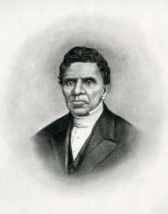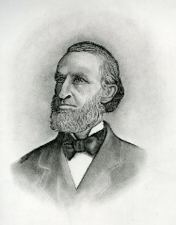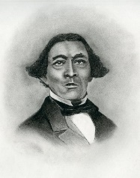
Robert Everett Calvin Fairbank Stephen Myers

Please send a registration to NAHOF, P.O. Box 55, Peterboro NY 13134
for each person separately.
Thank you.
NAME:
STREET &/or POSTAL ADDRESS:
TOWN, STATE, ZIP:
EMAIL:
PHONES:

DUE DATE | ACTIVITY | COST PER
9/1/22 | WEEKEND PROGRAMS:  Fri 7 pm Welsh Concert  Sat 10 am Tour Gerrit Smith Estate NHL  Sat 11 am Hall of Fame and Museum Opens  (Sat 12:30 pm NAHOF Annual Meeting)  Sat Abolition Symposia  1:30 Robert Everett  2:30 Calvin Fairbank  3:30 Stephen Myers  Sat 5:00 pm 19th C. Antislavery Box Dinner  Sat 7:00 pm Inductions & Banner Unveiling  Sun 2:00 pm Florence Farming Settlement  Sun 3:00 pm Fairbank Home | $50  For all Weekend Programs
9/1/22 | 5 pm 19th C. Antislavery Box Dinner  Due to COVID and its consequences the Peterboro United Methodist Church is providing a separate prepared dinner for each person. | $50
Optional | Yes, I will sponsor the 31”x 84” retractable vinyl banner for Inductee _______________  1st line of Inductee Banner: Name, town, state:  __________________________________________________  2nd line of Inductee Banner: Association with inductee:  ____________________________________________________ | $100
Optional | Annual National Abolition Hall of Fame and Museum Membership  New Annual Member receives 1 free book from Milton C. Sernett PhD  Choose North Star Country or Abolition’s AXE (Please circle book choice.) | $55
Optional | Annual National Abolition Hall of Fame and Museum Membership  New Lifetime Member receives 2 free books from Milton C. Sernett PhD  North Star Country and Abolition’s AXE | $200
Optional | Donation to National Abolition Hall of Fame and Museum
 | TOTAL

NAHOF INDUCTION 2022 REGISTRATION 7-15-22

